**Write a program to implement a Stack using two Queues**

#include <stdio.h>

#include<conio.h>

#define N 20

//declaring two queues and there fron and rear variables

int queue1[N],queue2[N];

int f1= -1, r1= -1;

int f2= -1, r2= -1;

int count=0;

//declaring two queues operations

void enqueue1(int x);

int dequeue1();

void enqueue2(int x);

int dequeue2();

//declaring stack operations

void push(int x);

int pop();

void display();

//main function

void main()

{ //declaring local variable

int ch, num; clrscr(); while (ch != 4)

{ //input user choice

printf("\n1.Push Item\n2.Pop Item\n3.Display Item\n4.Exit\n");

printf("\nEnter your choice :");

scanf("%d", &ch);

switch (ch)

{

case 1: printf("Entre item to be inserted : ");

scanf("%d", &num);

push(num); //insert function call

break;

case 2: printf("Item deleted : %d",pop()); //delete function call break;

case 3: display(); //printing stack elements

break;

case 4: exit(0);

break; //exit

default:printf("\nInvalide Choice !!!\n"); //invalid input

}

}

}

//enqueue operation for queue 1

void enqueue1(int x)

{

if(r1==N-1)

{

printf("Overflow");

}

else

{

if(f1== -1)

{

f1=0;

}

r1=r1+1;

queue1[r1]=x;

}

}

//dequeue operation for queue 1

int dequeue1()

{

int temp;

if(f1== -1 || f1 > r1)

{

printf("underflow");

}

else

{

temp = queue1[f1];

f1++;

}

return(temp);

}

//enqueue operation for queue 2

void enqueue2(int x)

{

if(r2==N-1)

{

printf("Overflow");

}

else

{

if(f2== -1)

{

f2=0;

}

r2=r2+1;

queue2[r2]=x;

}

}

//dequeue operation for queue 2

int dequeue2()

{

int temp;

if(f2== -1 || f2 > r2)

{

printf("Underflow");

}

else

{

temp = queue2[f2];

f2++;

}

return(temp);

}

// push functon to insert data into stack of two Queues

void push(int x)

{

int i;

enqueue1(x);

for (i = 0; i < count ; i++)

{

enqueue1(dequeue2());

}

count++;

for(i=0; i<count;i++)

{

enqueue2(dequeue1());

}

}

* pop function to delete data from stack of two Queues int pop()

{

count--;

return dequeue2();

}

* displaying the data of stack of two Queue

void display()

{

int i;

printf("\nElements in Stack : ");

for (i = f2; i <=r2 ; i++)

{

printf("%d ", queue2[i]);

}

printf("\n");

}

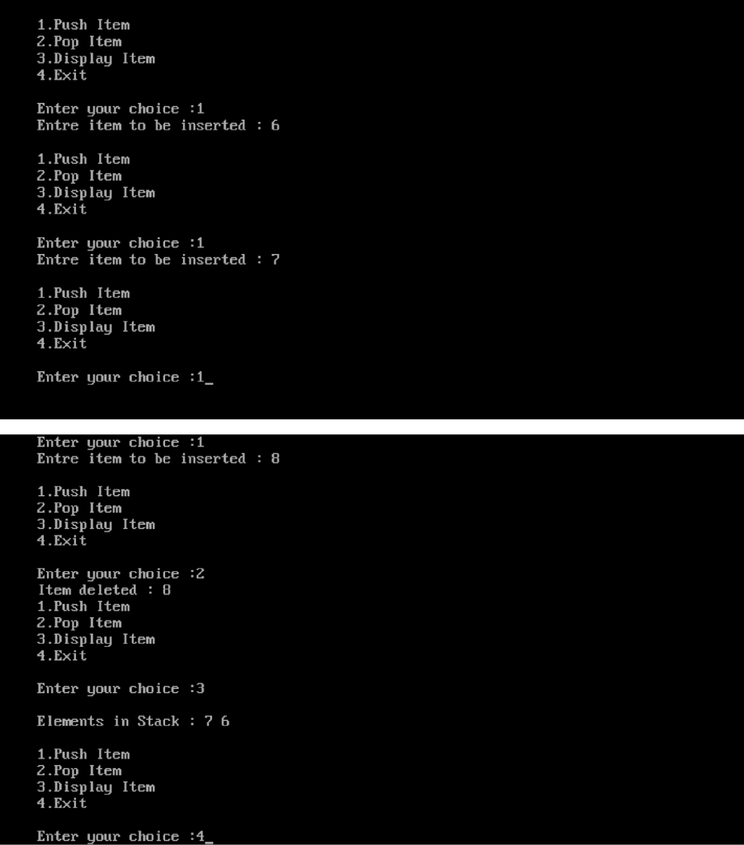

**Write a program to implement a Queue using two stacks.**

#include<stdio.h>

#include<stdlib.h>

#define N 10

int s1[N],s2[N];

int top1=-1;

int top2=-1;

int count=0;

void enqueue(int x);

void deque();

void push1(int x);

void push2(int x);

int pop1();

int pop2();

void display();

void main()

{

int ch,x;

while(1)

{

printf("\n 1. Insert");

printf("\n 2. Delete");

printf("\n 3. Display");

printf("\n 4. Exit");

printf("\n Enter your choice: ");

scanf("%d", &ch);

switch(ch)

{

case 1: printf("\n enter the number: ");

scanf("%d", &x);

enqueue(x);

break;

case 2: deque();

break;

case 3: display();

break;

case 4: exit(0);

default: printf("wrong choice");

}

}

}

void enqueue(int x)

{

push1(x);

count++;

}

void push1(int x)

{

if(top1 == N-1)

{

printf("\n stack is full");

}

else

{

top1++;

s1[top1]=x;

}

}

void push2(int x)

{

if(top2 == N-1)

{

printf("\n stack is full");

}

else

{

top2++;

s2[top2]=x;

}

}

int pop1()

{

return(s1[top1--]);

}

int pop2()

{

return(s2[top2--]);

}

void deque()

{

int i,a,b;

if(top1 == -1 && top2 == -1)

{

printf("\n stack is empty");

}

else

{

for(i=0;i<count;i++)

{

a=pop1();

push2(a);

}

b=pop2();

printf("\n deleted element is : %d", b);

count--;

for(i=0;i<count;i++)

{

a=pop2();

push1(a);

}

}

}

void display()

{

int i;

for(i=0;i<=top1;i++)

{

printf(" %d ",s1[i]);

}

}

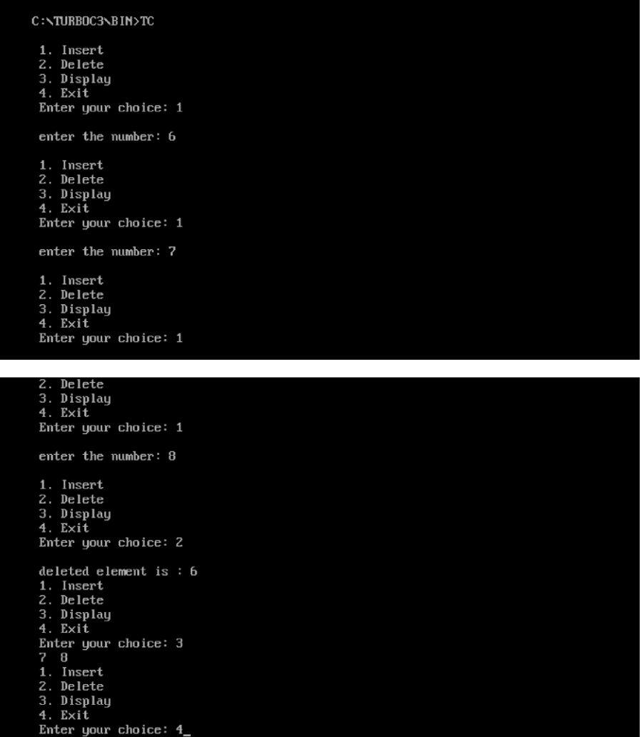

Write programs to implement the following data structures: (a) Single Linked list

#include <stdio.h>

#include <stdlib.h>

struct Node

{

int data;

struct Node* next;

};

struct Node* head = NULL;

struct Node* ptr, *temp;

void insert_begin();

void insert_last();

void insert_position();

void delete_begin();

void delete_last();

void delete_position();

void search();

void display();

void main()

{

int choice;

while (1)

{

printf("\n\n*** Linked List Operations ***\n");

printf("1. Insert at Beginning\n");

printf("2. Insert at End\n");

printf("3. Insert at Position\n");

printf("4. Delete from Beginning\n");

printf("5. Delete from End\n");

printf("6. Delete from Position\n");

printf("7. Search\n");

printf("8. Display\n");

printf("9. Exit\n");

printf("Enter your choice: ");

scanf("%d", &choice);

switch (choice)

{

case 1: insert_begin(); break;

case 2: insert_last(); break;

case 3: insert_position(); break;

case 4: delete_begin(); break;

case 5: delete_last(); break;

case 6: delete_position(); break;

case 7: search(); break;

case 8: display(); break;

case 9: exit(0); break;

default: printf("Invalid choice, please try again\n");

}

}

}

void insert_begin()

{

int val;

ptr = (struct Node*) malloc(sizeof(struct Node));

if (ptr == NULL)

{

printf("Memory is not allocated\n");

}

else

{

printf("\nEnter Value: ");

scanf("%d", &val);

ptr->data = val;

ptr->next = head;

head = ptr;

printf("\nNode inserted at the beginning\n");

}

}

void insert_last()

{

int val;

ptr = (struct Node*) malloc(sizeof(struct Node));

if (ptr == NULL)

{

printf("Memory is not allocated\n");

}

else

{

printf("\nEnter Value: ");

scanf("%d", &val);

ptr->data = val;

ptr->next = NULL;

if (head == NULL)

{

head = ptr;

}

else

{

temp = head;

while (temp->next != NULL)

{

temp = temp->next;

}

temp->next = ptr;

}

printf("\nNode inserted at the end\n");

}

}

void insert_position()

{

int i, pos, val;

printf("\nEnter location: ");

scanf("%d", &pos);

ptr = (struct Node*) malloc(sizeof(struct Node));

if (ptr == NULL)

{

printf("\nMemory is not Allocated\n");

}

else

{

printf("\nEnter value: ");

scanf("%d", &val);

ptr->data = val;

if (pos == 1)

{

ptr->next = head;

head = ptr;

}

else

{

temp = head;

for (i = 1; i < pos - 1; i++)

{

temp = temp->next;

}

if (temp == NULL)

{

printf("\nCan't Insert");

}

else

{

ptr->next = temp->next;

temp->next = ptr;

printf("\nNode inserted at position %d\n", pos);

}

}

}

}

void delete_begin()

{

if (head == NULL)

{

printf("Linked List is empty\n");

}

else

{

temp = head;

printf("\n%d is deleted\n", head->data);

head = head->next;

free(temp);

}

}

void delete_last()

{

if (head == NULL)

{

printf("Linked List is empty\n");

}

else if (head->next == NULL)

{

printf("\n%d is deleted\n", head->data);

free(head);

head = NULL;

}

else

{

struct Node* temp1 = head;

while (temp1->next->next != NULL)

{

temp1 = temp1->next;

}

printf("\n%d is deleted\n", temp1->next->data);

free(temp1->next);

temp1->next = NULL;

}

}

void delete_position()

{

int pos, i;

if (head == NULL)

{

printf("Linked List is empty\n");

}

else

{

printf("\nEnter Position: ");

scanf("%d", &pos);

temp = head;

if (pos == 1)

{

printf("\n%d is deleted\n", head->data);

head = head->next;

free(temp);

}

else

{

struct Node* temp1;

for (i = 1; i < pos; i++)

{

temp = temp->next;

}

if (temp == NULL)

{

printf("\n Cant delete");

}

else

{

temp1 = temp->next;

printf("\n%d is deleted\n", temp1->data);

temp->next = temp1->next;

free(temp1);

}

}

}

}

void search()

{

int val, i = 0, flag = 0;

if (head == NULL)

{

printf("Linked List is empty\n");

}

else

{

printf("\nEnter value to search: ");

scanf("%d", &val);

temp = head;

while (temp != NULL)

{

if (temp->data == val)

{

printf("\n%d found at location %d\n", val, i + 1);

flag = 1;

break;

}

i++;

temp = temp->next;

}

if (!flag)

{

printf("\nValue %d not found\n", val);

}

}

}

void display()

{

if (head == NULL)

{

printf("Linked List is empty\n");

}

else

{

temp = head;

printf("\nLinked List: ");

while (temp != NULL)

{

printf("%d -> ", temp->data);

temp = temp->next;

}

printf("NULL\n");

}

}

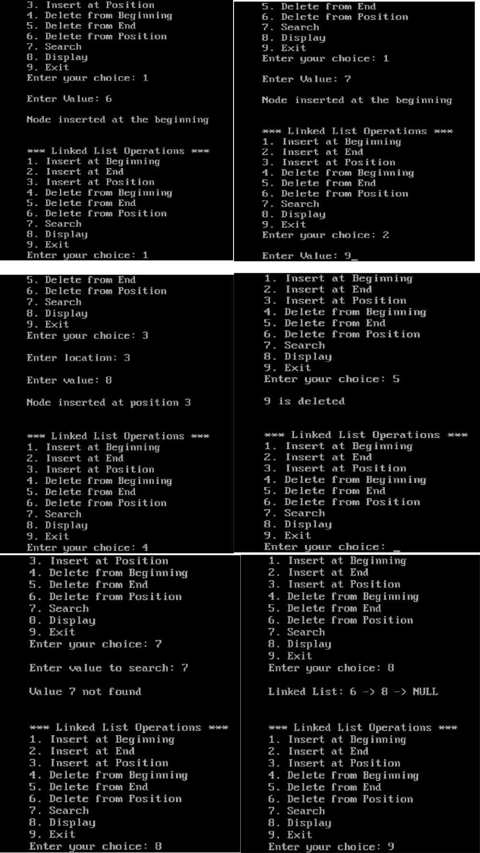

Write programs to implement the following data structures: (b) Double Linked list.

#include <stdio.h>

#include <stdlib.h>

struct Node

{

int data;

struct Node* prev;

struct Node* next;

};

struct Node* head = NULL;

struct Node* ptr;

struct Node*temp, *temp1;

int val, flag=0, i=0, loc, pos;

void insert_begin();

void insert_last();

void insert_position();

void delete_begin();

void delete_last();

void delete_position();

void search();

void display();

void main()

{

int choice;

while (1)

{

printf("\n\n*** Doubly Linked List Operations ***\n");

printf("1. Insert at Beginning\n");

printf("2. Insert at End\n");

printf("3. Insert at Position\n");

printf("4. Delete from Beginning\n");

printf("5. Delete from End\n");

printf("6. Delete from Position\n");

printf("7. Search\n");

printf("8. Display\n");

printf("9. Exit\n");

printf("Enter your choice: ");

scanf("%d", &choice);

switch (choice)

{

case 1: insert_begin(); break;

case 2: insert_last(); break;

case 3: insert_position(); break;

case 4: delete_begin(); break;

case 5: delete_last(); break;

case 6: delete_position(); break;

case 7: search(); break;

case 8: display(); break;

case 9: exit(0); break;

default: printf("Invalid choice, please try again\n");

}

}

}

void insert_begin()

{

ptr = (struct Node*) malloc(sizeof(struct Node));

if (ptr == NULL)

{

printf("Memory is not allocated\n");

}

else

{

printf("\nEnter Value: ");

scanf("%d", &val);

if (head == NULL)

{

ptr->data = val;

ptr->prev = NULL;

ptr->next = NULL;

head = ptr;

}

else

{

ptr->data = val;

ptr->prev = NULL;

ptr->next = head;

head->prev = ptr;

head = ptr;

}

}

printf("\nNode inserted at the beginning\n");

}

void insert_last()

{

ptr = (struct Node*) malloc(sizeof(struct Node));

if (ptr == NULL)

{

printf("Memory is not allocated\n");

}

else

{

printf("\nEnter Value: ");

scanf("%d", &val);

if (head == NULL)

{

ptr->data = val;

ptr->next = NULL;

ptr->prev = NULL;

head = ptr;

}

else

{

temp = head;

while (temp->next != NULL)

{

temp = temp->next;

}

ptr->data = val;

ptr->next = NULL;

temp->next = ptr;

ptr->prev = temp;

}

}

printf("\nNode inserted at the end\n");

}

void insert_position()

{

ptr = (struct Node*) malloc(sizeof(struct Node));

if (ptr == NULL)

{

printf("\nMemory is not Allocated\n");

}

else

{

printf("\nEnter location: ");

scanf("%d", &pos);

temp = head;

for (i = 0; i < pos ; i++)

{

if (temp == NULL)

{

printf("\nCan't Insert");

}

}

printf("\nEnter Value");

scanf("%d",&val);

ptr-> data = val;

ptr->prev = temp;

ptr->next = temp->next;

temp->next = ptr;

}

printf("\nNode inserted at position %d\n", pos);

}

void delete_begin()

{

if (head == NULL)

{

printf("Doubly Linked List is empty\n");

}

else

{

temp = head;

printf("\n%d is deleted\n", head->data);

head = head->next;

head->prev = NULL;

temp->next = NULL;

free(temp);

}

}

void delete_last()

{

if (head == NULL)

{

printf("Doubly Linked List is empty\n");

}

else

{

temp = head;

while (temp->next != NULL)

{

temp = temp->next;

}

printf("\n%d is deleted\n", temp->data);

temp->prev->next = NULL;

temp->prev=NULL;

free(temp);

}

}

void delete_position()

{

if (head == NULL)

{

printf("Doubly Linked List is empty\n");

}

else

{

temp=head;

printf("\nEnter Position: ");

scanf("%d", &pos);

for (i = 0; i < pos; i++)

{

temp = temp->next;

if (temp == NULL)

{

printf("\n Can't Delete");

}

}

printf("\n%d is deleted\n", temp->data);

temp->prev->next = temp->next;

temp->next->prev = temp->prev;

temp->next =NULL;

temp->prev =NULL;

free(temp);

}

}

void search()

{

if (head == NULL)

{

printf("Doubly Linked List is empty\n");

}

else

{

printf("\nEnter value to search: ");

scanf("%d", &val);

temp = head;

while (temp != NULL)

{

if (temp->data == val)

{

printf("\n%d found at location %d\n", val, i);

flag = 1;

break;

}

i++;

temp = temp->next;

}

if (!flag)

{

printf("\nValue %d not found\n", val);

}

}

}

void display()

{

if (head == NULL)

{

printf("Doubly Linked List is empty\n");

}

else

{

temp = head;

printf("\nDoubly Linked List: ");

while (temp != NULL)

{

printf("%d <-> ", temp->data);

temp = temp->next;

}

printf("NULL\n");

}

}

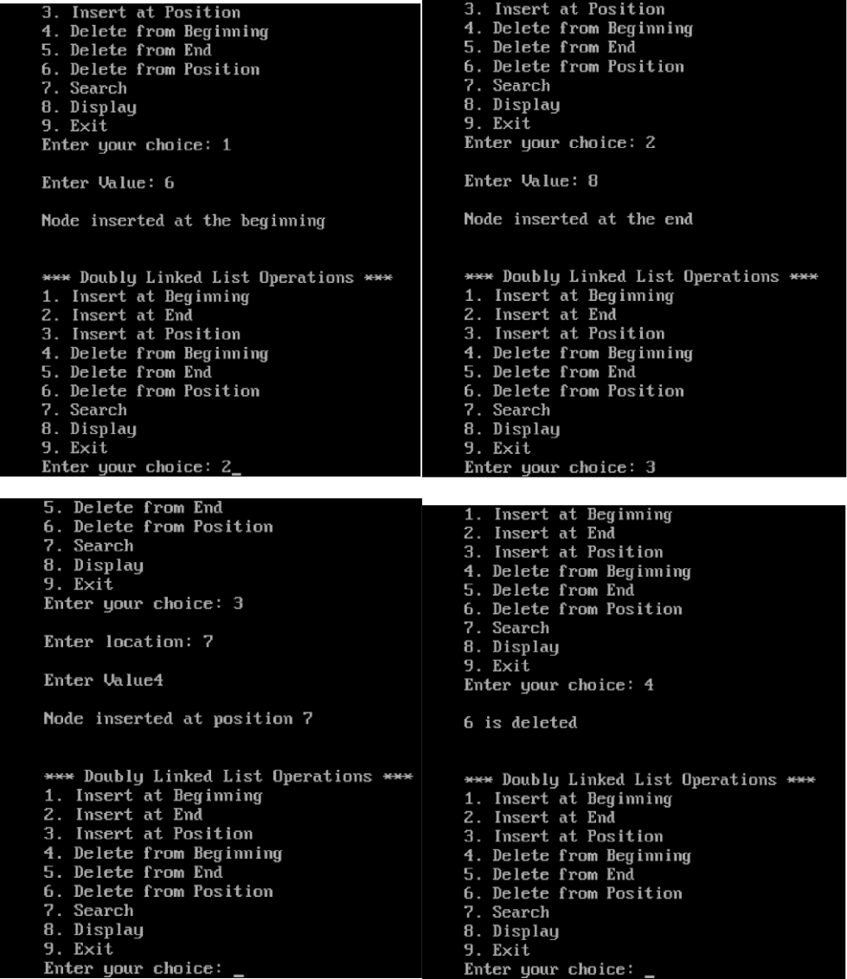

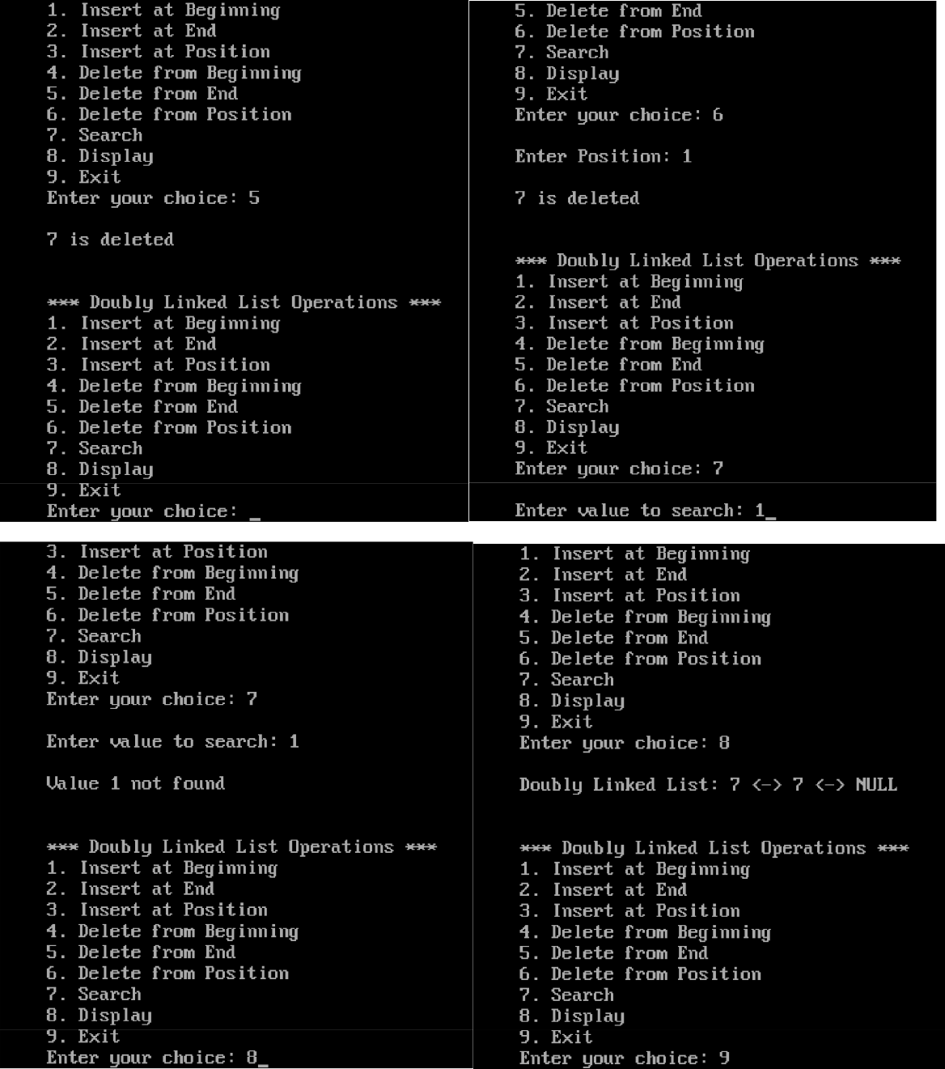

**Write a program to implement the Circular Singly linked list**

#include <stdio.h>

#include <stdlib.h>

struct Node

{

int data;

struct Node* next;

};

struct Node* head = NULL;

struct Node* ptr, *temp, *temp1;

int val,i,pos,flag=0;

void insert_begin();

void insert_last();

void insert_position();

void delete_begin();

void delete_last();

void delete_position();

void search();

void display();

void main()

{

int choice;

while (1)

{

printf("\n\n1. Insert at Beginning\n");

printf("2. Insert at End\n");

printf("3. Insert at Position\n");

printf("4. Delete from Beginning\n");

printf("5. Delete from End\n");

printf("6. Delete from Position\n");

printf("7. Search\n");

printf("8. Display\n");

printf("9. Exit\n");

printf("Enter your choice: ");

scanf("%d", &choice);

switch (choice)

{

case 1: insert_begin(); break;

case 2: insert_last(); break;

case 3: insert_position(); break;

case 4: delete_begin(); break;

case 5: delete_last(); break;

case 6: delete_position(); break;

case 7: search(); break;

case 8: display(); break;

case 9: exit(0); break;

default: printf("Invalid choice, please try again\n");

}

}

}

void insert_begin()

{

ptr = (struct Node*) malloc(sizeof(struct Node));

if (ptr == NULL)

{

printf("Memory is not allocated\n");

}

else

{

printf("\nEnter Value: ");

scanf("%d", &val);

if (head == NULL)

{

ptr->data = val;

head = ptr;

ptr->next = head;

}

else

{

temp = head;

while (temp->next != head)

{

temp = temp->next;

}

ptr->data = val;

ptr->next = head;

head = ptr;

temp->next = ptr;

}

printf("\nNode inserted at the beginning\n");

}

}

void insert_last()

{

ptr = (struct Node*) malloc(sizeof(struct Node));

if (ptr == NULL)

{

printf("Memory is not allocated\n");

}

else

{

printf("\nEnter Value: ");

scanf("%d", &val);

if (head == NULL)

{

ptr->data = val;

head = ptr;

ptr->next = ptr;

}

else

{

temp = head;

while (temp->next != head)

{

temp = temp->next;

}

ptr->data = val;

temp->next = ptr;

ptr->next = head;

}

printf("\nNode inserted at the end\n");

}

}

void insert_position()

{

int i, pos, val;

printf("\nEnter location: ");

scanf("%d", &pos);

ptr = (struct Node*) malloc(sizeof(struct Node));

if (ptr == NULL)

{

printf("\nMemory is not Allocated\n");

}

else

{

printf("\nEnter value: ");

scanf("%d", &val);

ptr->data = val;

if (pos == 1)

{

ptr->next = head;

head = ptr;

}

else

{

temp = head;

for (i = 1; i < pos - 1; i++)

{

temp = temp->next;

}

if (temp == NULL)

{

printf("\nCan't Insert");

}

else

{

ptr->next = temp->next;

temp->next = ptr;

printf("\nNode inserted at position %d\n", pos); }

}

}

}

void delete_begin()

{

if (head == NULL)

{

printf("Circular Linked List is empty\n");

}

else

{

temp = head;

while (temp->next != head)

{

temp = temp->next;

}

printf("\n%d is deleted\n", head->data);

temp1 = head;

head = head->next;

temp->next = head;

temp1->next = NULL;

free(temp1);

}

}

void delete_last()

{

if (head == NULL)

{

printf("Circular Linked List is empty\n");

}

else

{

temp = head;

while (temp->next!= head)

{

temp1 = temp;

temp = temp->next;

}

printf("\n%d is deleted\n", temp->data);

temp1->next = head;

free(temp);

}

}

void delete_position()

{

int pos, i;

if (head == NULL)

{

printf("Linked List is empty\n");

}

else

{

printf("\nEnter Position: ");

scanf("%d", &pos);

temp = head;

if (pos == 1)

{

printf("\n%d is deleted\n", head->data);

head = head->next;

free(temp);

}

else

{

struct Node* temp1;

for (i = 1; i < pos-1; i++)

{

temp = temp->next;

}

if (temp == NULL)

{

printf("\n Cant delete");

}

else

{

temp1 = temp->next;

printf("\n%d is deleted\n", temp1->data);

temp->next = temp1->next;

free(temp1);

}

}

}

}

void search()

{

int val, i = 0, flag = 0;

if (head == NULL)

{

printf("Linked List is empty\n");

}

else

{

printf("\nEnter value to search: ");

scanf("%d", &val);

temp = head;

while (temp != NULL)

{

if (temp->data == val)

{

printf("\n%d found at location %d\n", val, i + 1);

flag = 1;

break;

}

i++;

temp = temp->next;

}

if (!flag)

{

printf("\nValue %d not found\n", val);

}

}

}

void display()

{

if (head == NULL)

{

printf("Circular Linked List is empty\n");

}

else

{

temp = head;

printf("\nCircular Linked List: ");

do

{

printf("%d -> ", temp->data);

temp = temp->next;

}

while (temp != head);

}

}

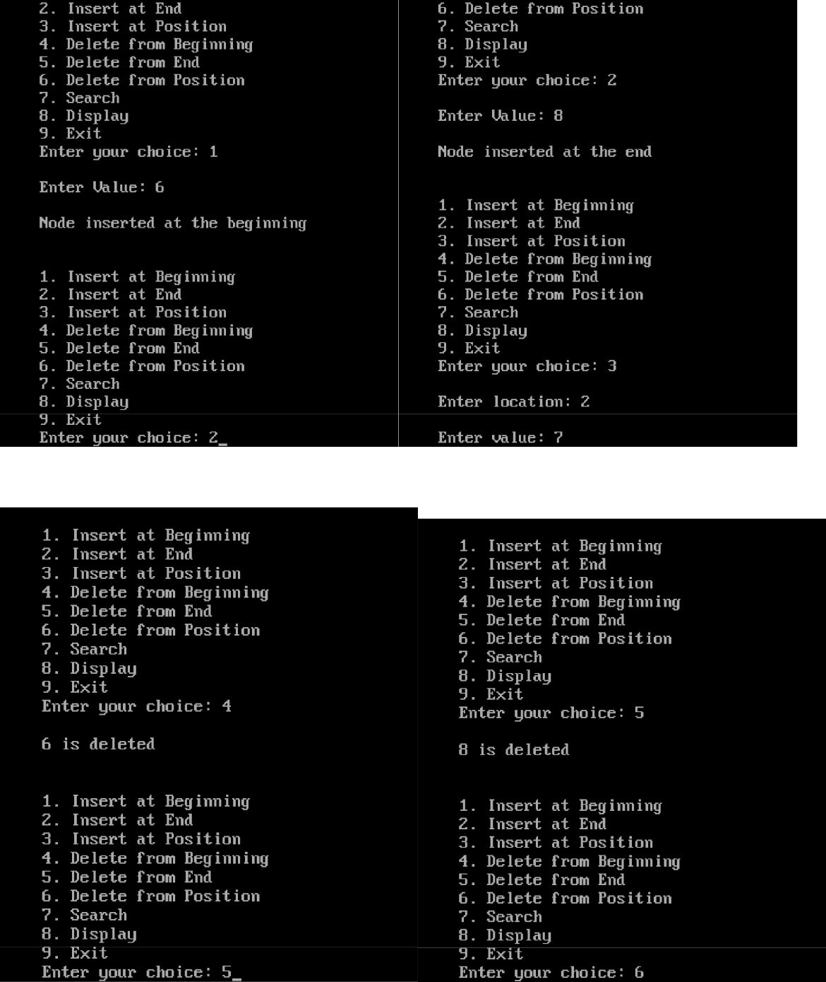

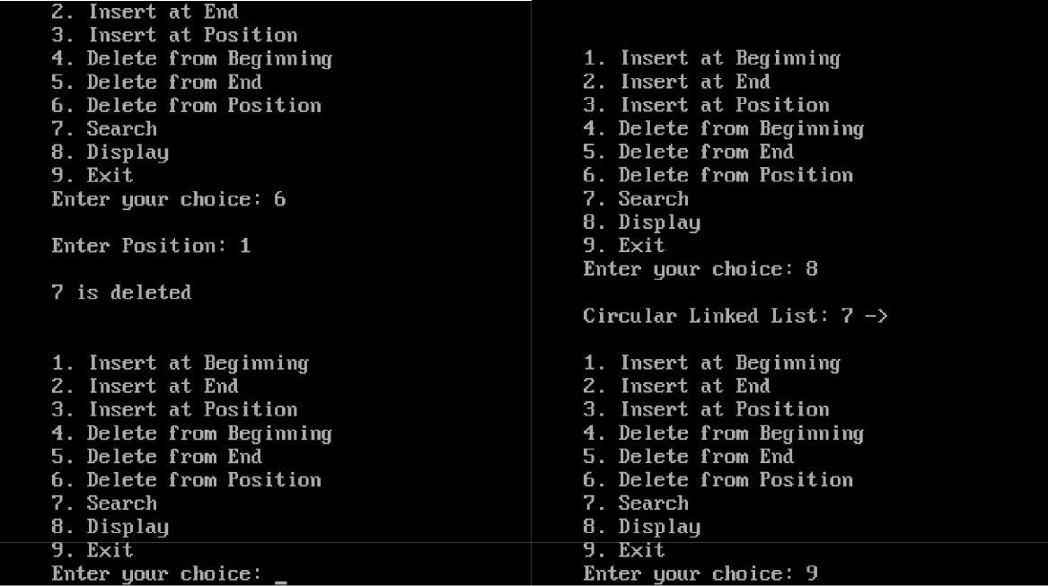

**Write a program to implement Binary Tree**.

#include<stdio.h>

#include<conio.h>

#include<stdlib.h>

struct node

{

int data;

struct node *left;

struct node *right;

};

struct node *root= NULL;

**void** main()

{

int ch;

while(1)

{

printf(“1. Create\n 2. Inorder\n 3. Preorder\n 4. Postorder\n 5. Exit”);

printf(“\n Enter your choice: “);

scanf(“%d”,&ch);

switch(ch)

{

case 1: root = create();

break;

case 2: inorder(root);

break;

case 3: preorder(root);

break;

case 4: postorder(root);

break;

case 5: exit(0);

break;

default: printf(“\n Wrong Choice:”);

}

}

}

**struct** node *create()

{

**struct** node *temp;

**int** data;

temp = (**struct** node *)malloc(**sizeof**(**struct** node));

printf("Press 0 to exit");

printf("\n Press 1 for new node");

printf("Enter your choice : ");

scanf("%d", &choice);

**if**(choice==0)

{

**return** 0;

}

**else**

{

printf("Enter the data:");

scanf("%d", &data);

temp->data = data;

printf("Enter the left child of %d", data);

temp->left = create();

printf("Enter the right child of %d", data);

temp->right = create();

**return** temp;

}

}

void pre_order_traversal(struct node* root)

{

if(root != NULL)

{

printf("%d ",root->data);

pre_order_traversal(root->leftChild);

pre_order_traversal(root->rightChild);

}

}

void inorder_traversal(struct node* root)

{

if(root != NULL)

{

inorder_traversal(root->leftChild);

printf("%d ",root->data);

inorder_traversal(root->rightChild);

}

}

void post_order_traversal(struct node* root)

{

if(root != NULL)

{

post_order_traversal(root->leftChild);

post_order_traversal(root->rightChild);

printf("%d ", root->data);

}

}

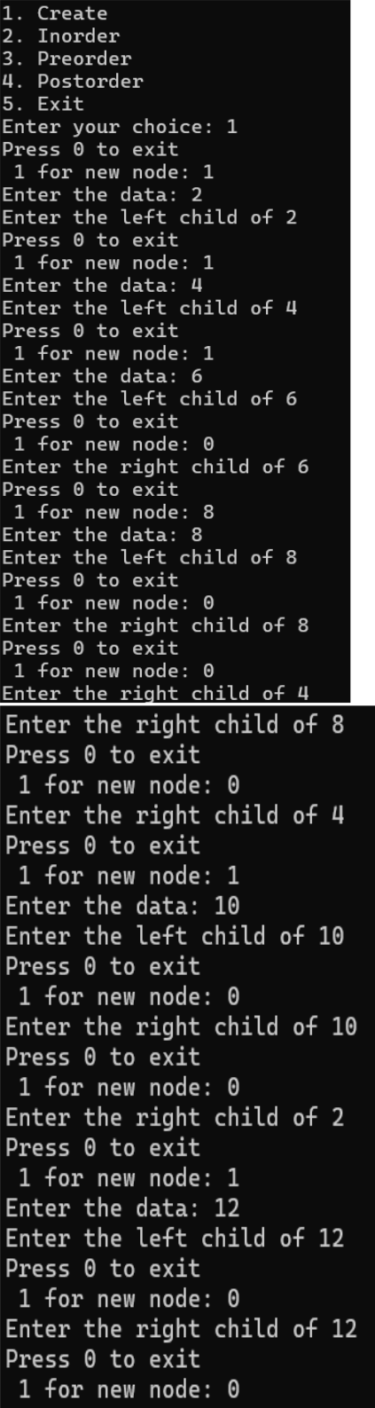

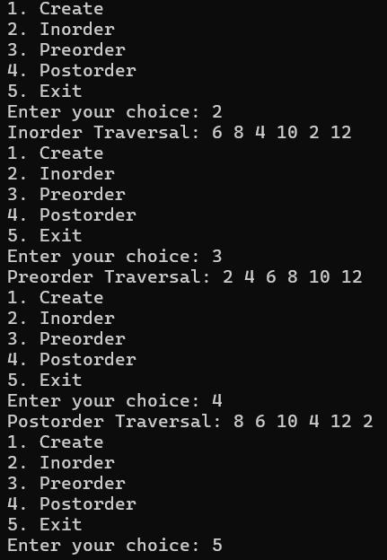

**Write a program to create a binary search tree (BST)**

#include<stdio.h>

#include<conio.h>

#include<stdlib.h>

struct node

{

int data;

struct node *left, *right;

};

struct node *createtree(struct node *root, int data);

void search(struct node *root);

void findmax(struct node *root);

struct node *delet(struct node *root, int data);

struct node *findmin(struct node *root);

void preorder(struct node *root);

void inorder(struct node *root);

void postorder(struct node *root);

struct node *root = NULL;

void main()

{

struct node *temp;

int data, ch, i, n;

while(1)

{

printf("\n1.Insertion in Binary Search Tree");

printf("\n2.Search Element in Binary Search Tree");

printf("\n3.Delete Element in Binary Search Tree");

printf("\n4.Inorder\n5.Preorder\n6.Postorder\n7.Find Min\n8.Find Max\n9.Exit");

printf("\nEnter your choice: ");

scanf("%d",&ch);

switch (ch)

{

case 1: printf("\nEnter how many nodes u want to insert: " ); scanf("%d", &n);

printf("\n enter values: ");

for(i=0; i<n; i++)

{

scanf("%d", &data);

root=createtree(root, data);

}

break;

case 2: search(root);

break;

case 3: printf("\nEnter the element to delete: ");

scanf("%d", &data);

root=delet(root, data);

break;

case 4: printf("\nInorder Traversal: \n");

inorder(root);

break;

case 5: printf("\nPreorder Traversal: \n");

preorder(root);

break;

case 6: printf("\nPostorder Traversal: \n");

postorder(root);

break;

case 7: temp=findmin(root);

printf("\n %d is minimum no in BST",temp->data); break;

case 8: findmax(root);

break;

case 9: exit(0);

default: printf("WRONG CHOICE");

break;

}

}

}

struct node *createtree(struct node *root, int data)

{

if (root == NULL)

{

struct node *temp;

temp= (struct node*)malloc(sizeof(struct node));

temp->data = data;

temp->left = NULL;

temp->right = NULL;

return(temp);

}

if (data < (root->data))

{

root->left = createtree(root->left, data);

}

else if (data > root->data)

{

root->right = createtree(root->right, data);

}

return root;

}

void preorder(struct node *root)

{

if(root != NULL)

{

printf("%d ",root->data);

preorder(root->left);

preorder(root->right);

}

}

void inorder(struct node *root)

{

if(root != NULL)

{

inorder(root->left);

printf("%d ",root->data);

inorder(root->right);

}

}

void postorder(struct node *root)

{

if(root != NULL)

{

postorder(root->left);

postorder(root->right);

printf("%d ", root->data);

}

}

struct node *delet(struct node *root, int data)

{

struct node *temp;

if(root == NULL)

{

printf("\nElement not found");

}

else if(data < root->data)

{

root->left = delet(root->left, data);

}

else if(data > root->data)

{

root->right = delet(root->right, data);

}

else

{

if(root->right && root->left)

{

temp = findmin(root->right);

root->data = temp->data;

root->right = delet(root->right,temp->data);

}

else

{

temp = root;

if(root->left == NULL)

root = root->right;

else if(root->right == NULL)

root = root->left;

free(temp); /* temp is longer required */

}

}

return root;

}

struct node *findmin(struct node *root)

{

struct node *temp;

temp = root;

if(temp==NULL)

{

return NULL;

}

if(temp->left)

return findmin(temp->left);

else

return temp;

}

void findmax(struct node *root)

{

if(root==NULL)

{

return;

}

if(root->right)

findmax(root->right);

else

printf("\n %d is maximum no in BST",root->data);

}

void search(struct node *root)

{

int data;

if(root == NULL)

{

printf("\nBST is empty.");

return;

}

printf("\nEnter Element to be searched: ");

scanf("%d", &data);

while(root != NULL)

{

if (root->data == data)

{

printf("\nKey element is present in BST");

return;

}

if (data < root->data)

root = root->left;

else

root = root->right;

}

printf("\nKey element is not found in the BST");

}

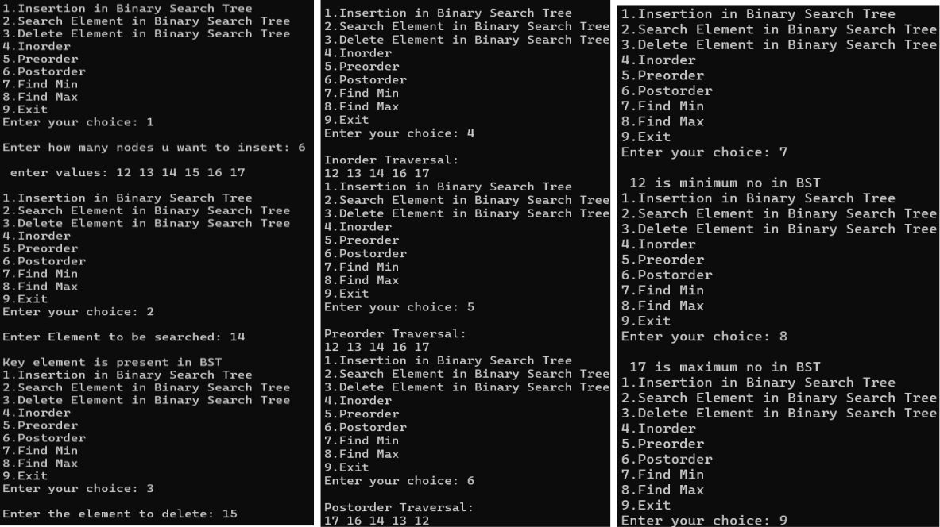

**Write programs for implementation of graph traversals by applying:**

**(a) BFS (b) DFS**

#include<stdio.h>

int q[20],top=-1,front=-1,rear=-1,a[20][20],vis[20],stack[20]; int delete();

void add(int item);

void bfs(int s,int n);

void dfs(int s,int n);

void push(int item);

int pop();

void main()

{

int n,i,s,ch,j;

char c,dummy;

printf("ENTER THE NUMBER VERTICES ");

scanf("%d",&n);

for(i=1;i<=n;i++)

{

for(j=1;j<=n;j++)

{

printf("ENTER 1 IF %d HAS A NODE WITH %d ELSE 0 ",i,j); scanf("%d",&a[i][j]);

}

}

printf("THE ADJACENCY MATRIX IS\n");

for(i=1;i<=n;i++)

{

for(j=1;j<=n;j++)

{

printf(" %d",a[i][j]);

}

printf("\n");

}

do

{

for(i=1;i<=n;i++)

vis[i]=0;

printf("\nMENU");

printf("\n1.B.F.S");

printf("\n2.D.F.S");

printf("\nENTER YOUR CHOICE");

scanf("%d",&ch);

printf("ENTER THE SOURCE VERTEX :");

scanf("%d",&s);

switch(ch)

{

case 1:bfs(s,n);

break;

case 2:dfs(s,n);

break;

}

printf("DO U WANT TO CONTINUE(Y/N) ? "); scanf("%c",&dummy);

scanf(" %c",&c); // Added space before %c }while((c=='y')||(c=='Y'));

}

void bfs(int s,int n)

{

int p,i;

add(s);

vis[s]=1;

p=delete();

if(p!=0)

printf(" %d",p);

while(p!=0)

{

for(i=1;i<=n;i++)

if((a[p][i]!=0)&&(vis[i]==0))

{

add(i);

vis[i]=1;

}

p=delete();

if(p!=0)

printf(" %d ",p);

}

for(i=1;i<=n;i++)

if(vis[i]==0)

bfs(i,n);

}

void add(int item)

{

if(rear==19)

printf("QUEUE FULL");

else

{

if(rear==-1)

{

q[++rear]=item;

front++;

}

else

q[++rear]=item;

}

}

int delete()

{

int k;

if((front>rear)||(front==-1))

return(0);

else

{

k=q[front++];

return(k);

}

}

void dfs(int s,int n)

{

int i,k;

push(s);

vis[s]=1;

k=pop();

if(k!=0)

printf(" %d ",k);

while(k!=0)

{

for(i=1;i<=n;i++)

if((a[k][i]!=0)&&(vis[i]==0))

{

push(i);

vis[i]=1;

}

k=pop();

if(k!=0)

printf(" %d ",k);

}

for(i=1;i<=n;i++)

if(vis[i]==0)

dfs(i,n);

}

void push(int item)

{

if(top==19)

printf("Stack overflow ");

else

stack[++top]=item;

}

int pop()

{

int k;

if(top==-1)

return(0);

else

{

k=stack[top--];

return(k);

}

}

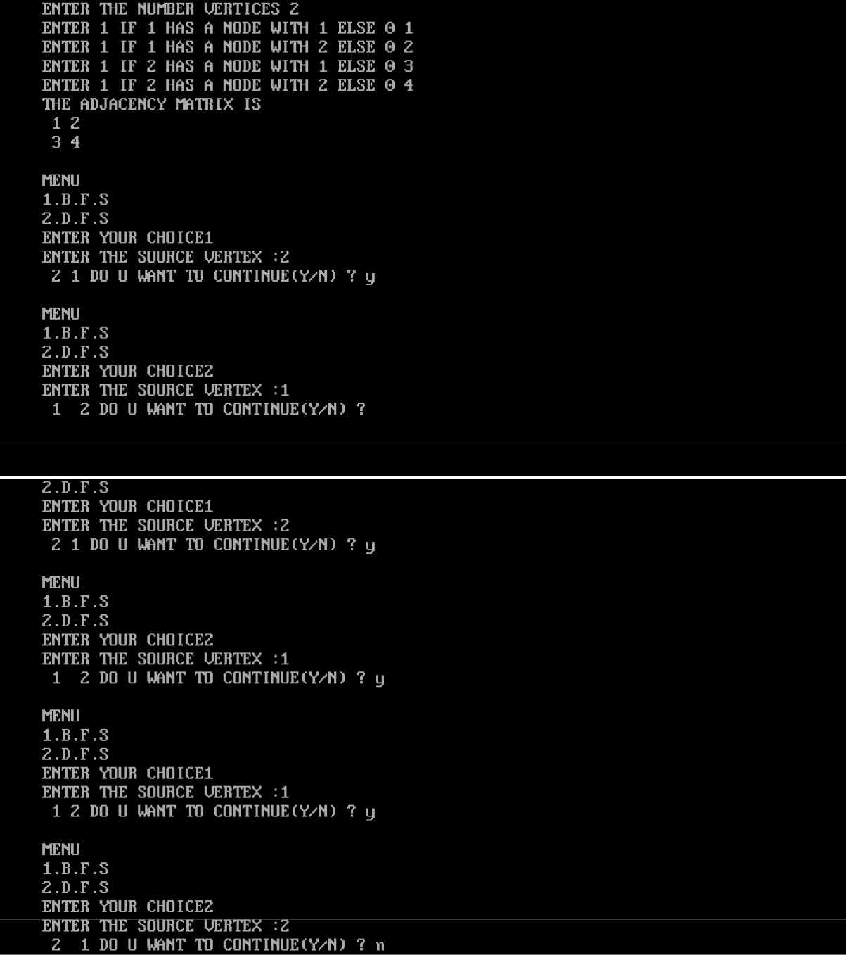

**Implement the following sorting algorithms:**

**(a) Insertion sort**

#include <stdio.h>

#include <conio.h> // Required for clrscr() and getch()

void insert(int a[], int n) /* function to sort an array with insertion sort */

{

int i, j, temp;

for (i = 1; i < n; i++)

{

temp = a[i];

j = i - 1;

while (j >= 0 && temp <= a[j])

{

a[j + 1] = a[j];

j = j - 1;

}

a[j + 1] = temp;

}

}

void printArr(int a[], int n) /* function to print the array */ {

int i;

for (i = 0; i < n; i++)

printf("%d ", a[i]);

}

void main()

{

int a[50]; // Fixed size array for Turbo C compatibility int n, i;

clrscr(); // Clear screen at start

printf("Enter the number of elements (max 50): "); scanf("%d", &n);

if (n > 50)

{

printf("Number of elements should not exceed 50."); getch(); // Wait for key press before exit return;

}

printf("Enter the elements:\n");

for (i = 0; i < n; i++)

{

scanf("%d", &a[i]);

}

printf("Before sorting, array elements are - \n");

printArr(a, n);

insert(a, n);

printf("\nAfter sorting, array elements are - \n"); printArr(a, n);

getch(); // Wait for key press before closing

}

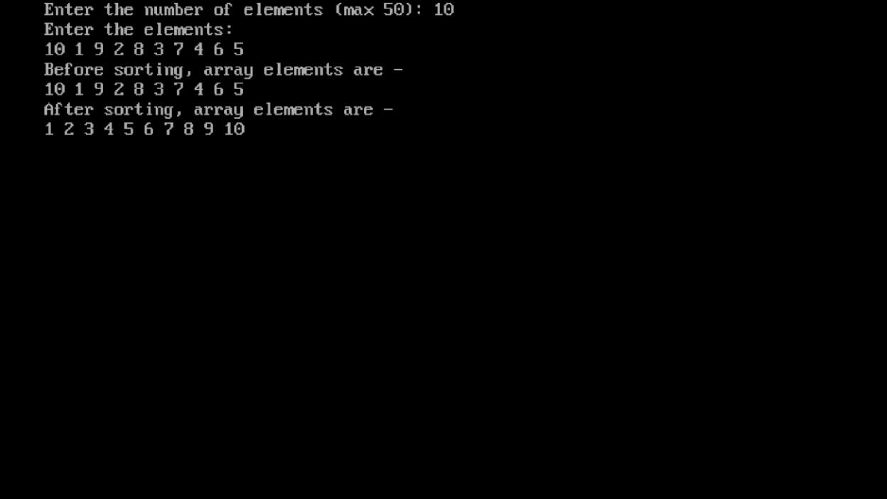

**Implement the following sorting algorithms:**

**(b) Selection Sort**

#include<stdio.h>

#include<conio.h>

#include<stdlib.h>

void selection_sort(int a[],int n);

void display(int a[], int n);

int a[10], n;

void main()

{

int i,ch;

clrscr();

printf("\n enter how many elements u want to insert: "); scanf("%d",&n);

printf("\n enter the elements: ");

for(i=0;i<n;i++)

{

scanf("%d",&a[i]);

}

while(1)

{

printf("\n1. Sort array");

printf("\n2. display sorted array");

printf("\n3. exit");

printf("\n Enter your choice: ");

scanf("%d", &ch);

switch(ch)

{

case 1: selection_sort(a,n);

printf("\n array is sorted: ");

break;

case 2: display(a,n);

break;

case 3: exit(0);

default: printf("\n wrong choice: ");

}

}

}

void selection_sort(int a[], int n)

{

int i,j,small, temp;

for(i=0;i<n-1;i++)

{

small=i;

for(j=i+1;j<n;j++)

{

if(a[j]<a[small])

{

small=j;

}

}

temp=a[small];

a[small]=a[i];

a[i]=temp;

}

}

void display(int a[], int n)

{

int i;

printf("\n sorted array is: ");

for(i=0;i<n;i++)

{

printf("\n %d",a[i]);

}

}

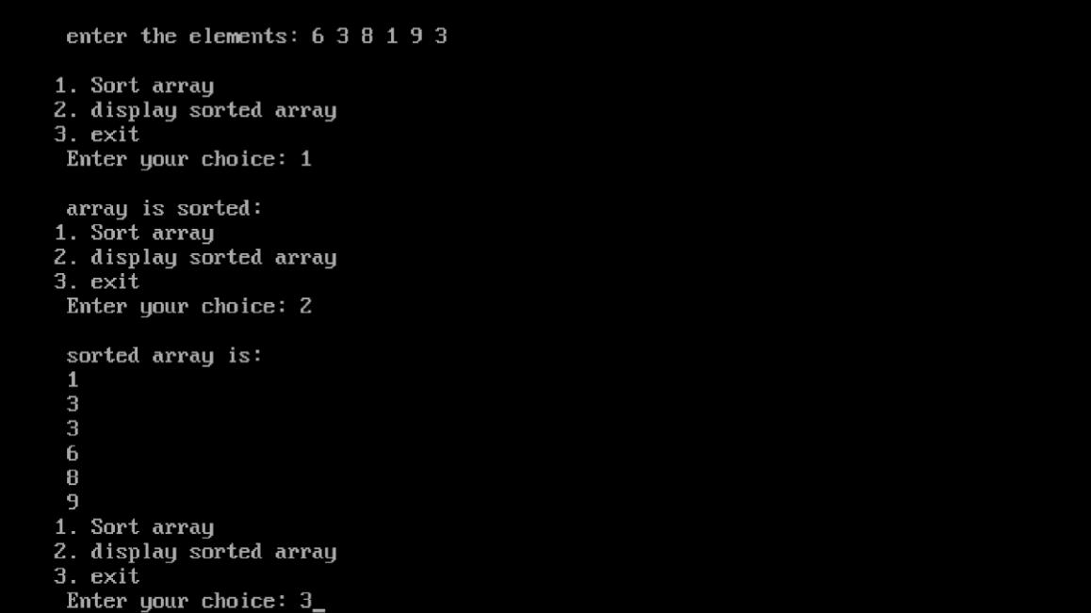

**Implement the following sorting algorithms:**

**(a) Quick sort**

#include<stdio.h>

#include<conio.h>

#include<stdlib.h>

void quicksort(int a[], int first, int last);

void main()

{

int i,n,a[20];

clrscr();

printf("\n Enter how many elements u want to enter: "); scanf("%d",&n);

printf("\n Enter the %d elemets in array: ",n);

for(i=0;i<n;i++)

{

scanf("%d", &a[i]);

}

quicksort(a,0,n-1);

printf("\n sorted array is: ");

for(i=0;i<n;i++)

{

printf(" %d ",a[i]);

}

getch();

}

void quicksort(int a[], int first, int last)

{

int i,j,pivot,temp;

if(first<last)

{

pivot=first;

i=first;

j=last;

while(i<j)

{

while(a[i]<=a[pivot] && i<last)

{

i++;

}

while(a[j]>a[pivot])

{

j--;

}

if(i<j)

{

temp=a[i];

a[i]=a[j];

a[j]=temp;

}

}

temp=a[pivot];

a[pivot]=a[j];

a[j]=temp;

quicksort(a,first,j-1);

quicksort(a,j+1,last);

}

}

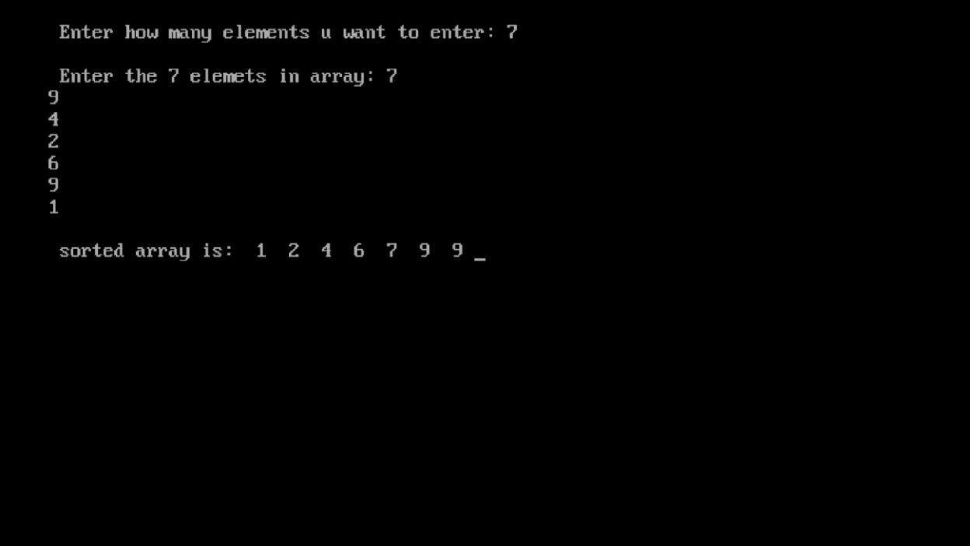

**Implement the following sorting algorithms:**

**(b) Merge sort**

#include<stdio.h>

#include<conio.h>

void mergesort(int a[], int lb, int ub);

void merge(int a[], int lb, int mid, int ub);

void main()

{

int i,n,a[20];

clrscr();

printf("\n Enter how many elements u want to enter: "); scanf("%d",&n);

printf("\n Enter the %d elemets in array: ",n);

for(i=0;i<n;i++)

{

scanf("%d", &a[i]);

}

mergesort(a,0,n-1);

printf("\n sorted array is: ");

for(i=0;i<n;i++)

{

printf(" %d ",a[i]);

}

getch();

}

void mergesort(int a[], int lb, int ub)

{

int mid;

if(lb<ub)

{

mid=(lb+ub)/2;

mergesort(a,lb,mid);

mergesort(a, mid+1,ub);

merge(a,lb,mid,ub);

}

}

void merge(int a[], int lb, int mid, int ub)

{

int i,j,k;

int b[20];

i=lb;

j=mid+1;

k=lb;

while(i<=mid && j<=ub)

{

if(a[i]<=a[j])

{

b[k]=a[i];

k++;

i++;

}

else

{

b[k]=a[j];

j++;

k++;

}

}

while(i<=mid)

{

b[k]=a[i];

i++;

k++;

}

while(j<=ub)

{

b[k]=a[j];

k++;

j++;

}

for(k=lb;k<=ub;k++) // Changed from k=0 to k=lb

{

a[k]=b[k];

}

}

